THE GREAT CHEESE HUNT

A NEW MICROMOUSE EVENT

TECHNICAL BULLETIN #4

PUBLICATION RIGHTS RESERVED

ADDRESS QUESTIONS TO:

DR. ANDREW R. SASS

IEEE, L.I. SECTION

arshacker@aol.com

IT IS ASSUMED THAT THE READER IS FAMILIAR WITH THE GREAT CHEESE HUNT - TECH BULLETIN #1, #2, AND #3.

This is a simple suggestion for all teams who wish to minimize component count on their Practice Beacon and cheese- hunt Mouse.

In the previous Bulletins, two LEDs, RED and GREEN and their associated current-limiting resistors, were used to signal the states of IR reception (and transmission for Option 1).

A RED and a GREEN LED and their current-limiting resistors are part of the Beacon and are also part of the Mouse.

In order to minimize number of components, the RED and GREEN LEDs and their associated current-limiting resistors, can be replaced by a single common-cathode RGB multicolor LED and a single current-limiting resistor. An inexpensive package of 100 RGB LEDs can be purchased for about $9. At

<https://a.co/d/gI7Pb0V>

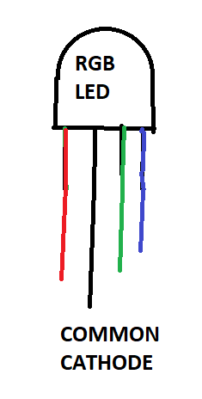

R and G can be wired to the ports designated in Tech Bulletin #1, Fig. 1, and B can be wired to system Ground (since BLUE is not used). A single current-limiting resistor can be wired from RGB LED common cathode to System Ground.

Fig. 1 in Tech Bulletin #1 is reproduced below with the RED and GREEN LEDs and their associated current=limiting resistors replaced by a RGB LED and a single current-limiting resistor; both in the Beacon and in the Mouse

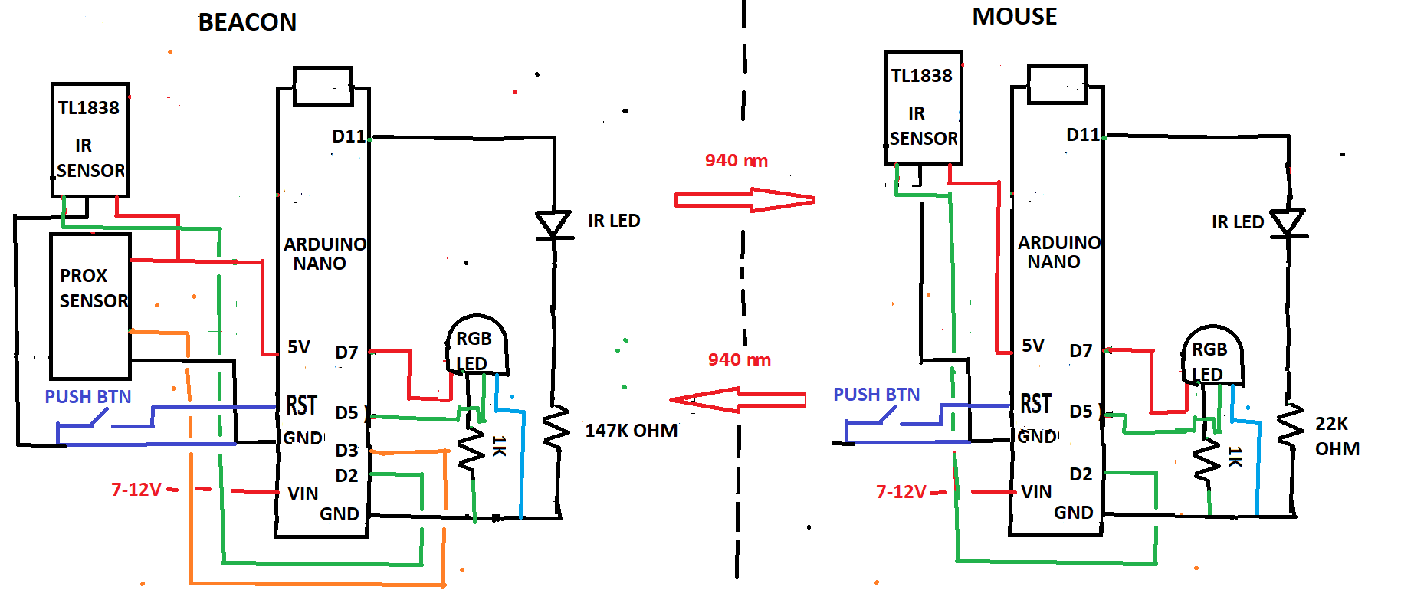

Fig. 1 from Tech Bulletin # 1 with RGB LED replacing RED and GREEN LEDS and resulting reduction in number of current-limiting resistors.

This replacement results in a reduction in component count in the Beacon and the Mouse.